Game Design Document

Fill up the Following document

1. Write the title of your project.

**Monkey go happy**

1. What is the goal of the game?

**Goal of the game is to collect banana**

**And protect monkey from stones .**

1. Write a brief story of your game?

**The monkey is hungry and wants to eat banana.**

1. Which are the playing characters of this game?

* Playing characters are the ones which respond to the user based on the input from the user
* Cars, monkeys, dinos, wizards etc, are the playing characters in the game.

|  |  |  |
| --- | --- | --- |
| Number | Character Name | What can this character do? |
| 1 | Monkey | Eat banana |
| 2 |  |  |
| 3 |  |  |
| 4 |  |  |
| 5 |  |  |
| 6 |  |  |
| 7 |  |  |
| 8 |  |  |

1. Which are the Non Playing Characters of this game?

* Non Playing characters are the ones which don't have an action or a behaviour when the user interacts with the game.
* Hurdles, stones, bananas, coins, etc are non playing characters in the game.

|  |  |  |
| --- | --- | --- |
| Number | Character Name | What can this character do? |
| 1 | stone | It can reduce health of monkey. |
| 2 | banana | It can increase the size of monkey. |
| 3 |  |  |
| 4 |  |  |
| 5 |  |  |
| 6 |  |  |
| 7 |  |  |
| 8 |  |  |

Draw your imagination of this game. What does this game look like?

* Draw the game either on your computer or on paper,
* Add images of scenes of the game to show each of the playing and non-playing characters at least once.

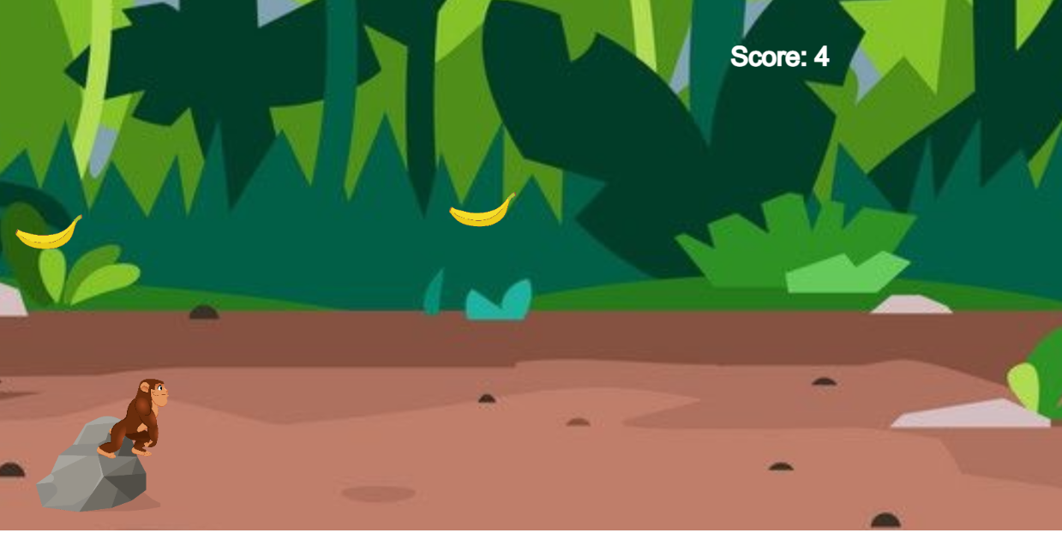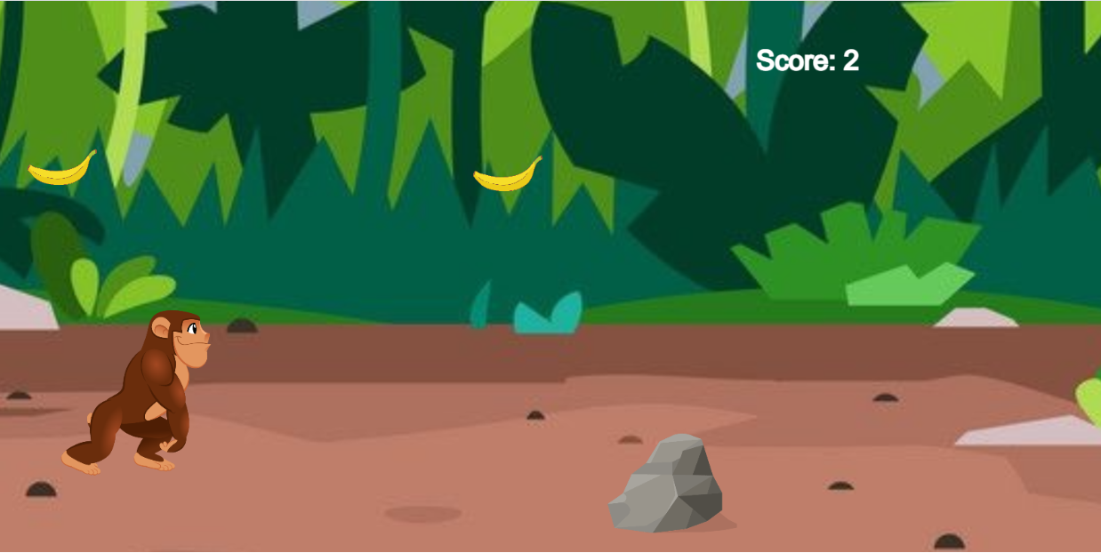

How do you plan to make your game engaging?

**the size of monkey would increase after eating banana . And there are only 2 health**

**So , the player would need to focus on saving health and scoring as much he can .**